**ORDER OF SERVICE**

Sunday November 8, 2020, 10:15 am

**“Where Do We Go from Here?”**

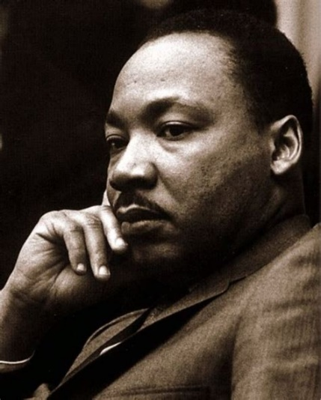

**Rev. Florence Caplow**

**Matthew Gladden, Piano**

**Herzog Family, Chalice**

**ElizaBeth Simpson, Puppet & Song Leading**

**Steve Troyer, AV**

*“In the days ahead we must not consider it unpatriotic to raise certain basic questions about our national character.”*

*–* Rev. Dr. Martin Luther King, from *Where Do We Go from Here*

**Prelude:** “We Would Be One” music by Jean Sibelius, arr. Saunder Choi, UU Community Church of Santa Monica

**Opening Words & Land Acknowledgment** Rev. Florence Caplow

**Chalice Lighting** offered by the Herzog Family

As we kindle this flame, we re-ignite our commitment to our congregational mission:

To build community, seek inspiration, promote justice, and find peace

**Parrot Learns a New Protest Song!** ElizaBeth Simpson

**Reading** from *Where Do We Go from Here* by Rev. Dr. Martin Luther King Jr.

**Community Matters** (videos from Mona Shannon, Jim Hannum, and UUCUC Youth)

**Offertory** "Impromptu in G-flat Major" by Franz Schubert

**Joys and Sorrows & Blessing Song** “May the Longtime Sun”

**Shared Joys and Sorrows** (send joys and sorrows to joysandsorrows@uucuc.org)

**Time of Music and Reflection**

**Reading** from *Caste: the Origins of Our Discontents* by Isabel Wilkerson

**Anthem** “Ella’s Song” (We Who Believe in Freedom Cannot Rest) sung by the choir of the UU Church of the Monterey Peninsula

**Reflection** “Where Do We Go from Here?” Rev. Florence Caplow

**Hymn #95** "There Is More Love Somewhere" sung by the choirs of Illinois UU congregations for “Democracy Revival”, October 27, 2020

**Closing Words & Blessing** “The Work of Citizenship”by A.R. Payson

**Postlude “**We Resist”, by Mark Miller, sung by the music directors of Illinois UU congregations for “Democracy Revival”, October 25, 2020

**Chalice Extinguishing** offered by the Herzog Family

We extinguish this flame, but not the light of truth, the warmth of community, or the fire of commitment. These we carry in our hearts until we are together again.

**Land Acknowledgment:** *We recognize and acknowledge that we gather today on indigenous land, taken through deception, coercion, and violence. We acknowledge the continued displacement and oppression of Native people and honor their commitments to survival, identity, and the protection of our world.*

**Readings today**

*Where Do We Go from Here: Chaos or Community*, by Martin Luther King, Jr., Beacon Prese, 1968

*Caste: The Origins of our Disontents* by Isabel Wilkerson, Random House, 2020

“The Work of Citizenship” by Aaron Payson

“Post-Election Poem” by Elizabeth Stevens

“Blessing” by Audette Fulbright